|  |  |
| --- | --- |
| TEAM ID | PNT2022TMID43481 |
| PROJECT TITLE | REAL-TIME RIVER WATER QUALITY MONITORING AND CONTROL SYSTEM |
| TEAM LEADER | VAISHNAVI R |
| TEAM MEMBER 1 | VARUNKUMAR N |
| TEAM MEMBER 2 | THAILA UMA A |
| TEAM MEMBER 3 | ROSHINI S |
| TEAM MEMBER 4 | NARMATHA S |

**TEAM LEAD :**

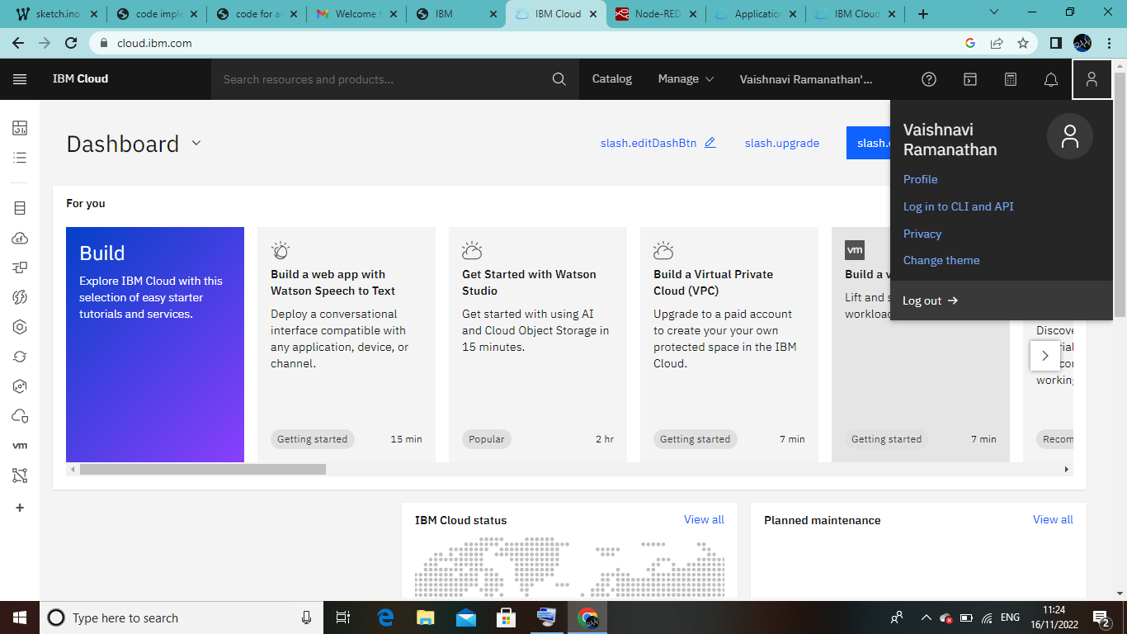

TEAM MEMBER 1 : VARUNKUMAR N

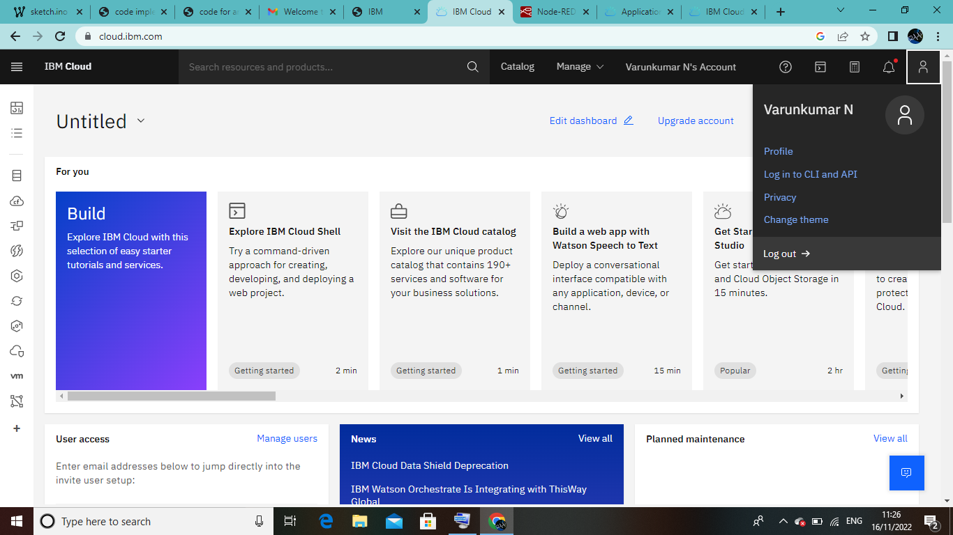

TEAM MEMBER 2 : THAILA UMA A

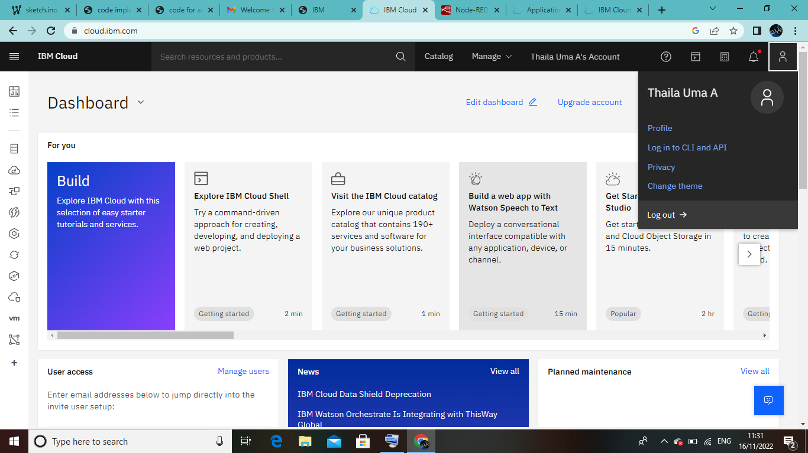

TEAM MEMBER 3 : ROSHINI S

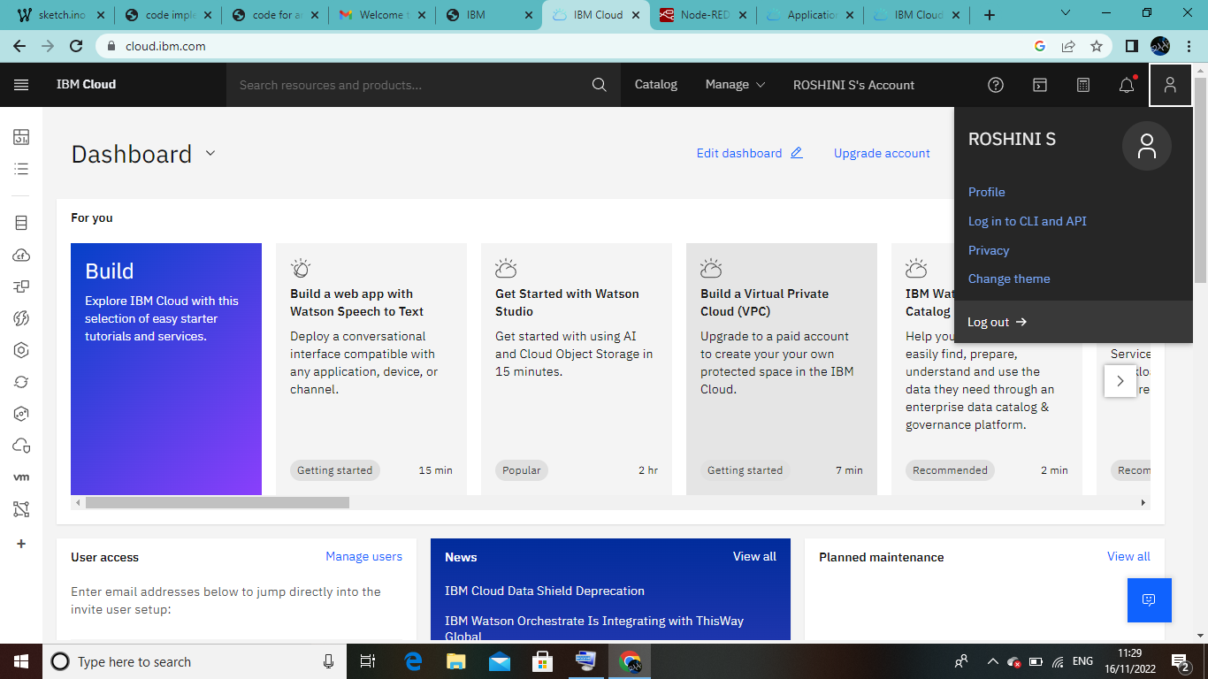

TEAM MEMBER 4 : NARMATHA S

